ABSTRACT
People find it hard to redirect audience to various other resources belonging to them and display lengthy URLs of the resource such as web-pages, documents, and social media handles. For the above-discussed problem coming up with an application which is component to: Web Pages similar to a portfolio that can identify users using username given by the user. Displaying the resources’ links in the profile that leads to other web-pages. Shortening the user provided links and the user managing the links in the profile. Also building the applications capable of CRUD operations such as user Sign Up; Log In; Updating Profile and managing links; Deleting Profiles and Links.

Keywords: Fuzzy, URL, Profile, Shortener.

ACKNOWLEDGEMENT

The satisfaction and euphoria that accompany the successful completion of any task would be impossible without the mention of the people who made it possible, whose constant guidance and encouragement crowned our efforts with success.

I have great pleasure in expressing gratitude to Dr. Mohan Manghnani, Chairman, New Horizon Educational Institutions, for providing necessary infrastructure and creating good environment.

I take this opportunity to express my profound gratitude to Dr. Manjunatha, Principal, New Horizon College of Engineering, for his constant support and encouragement.

I would like to thank Dr. Anandhi R J, Professor and Dean-Academics, NHCE, for her valuable guidance.

I would also like to thank Dr. B. Rajalakshmi, Professor and HOD, Department of Computer Science and Engineering, for her constant support.

I also express my gratitude to Ms. Shreenagamanjularani C , Senior Assistant Professor, Department of Computer Science and Engineering, my mini project reviewer, for constantly monitoring the development of the project and setting up precise deadlines. Her/His valuable suggestions were the motivating factors in completing the work.

TEJASHWIN U
USN: 1NH19CS238

CONTENTS
ABSTRACT | I
ACKNOWLEDGEMENT | II
CONTENTS | III
LIST OF FIGURES | V
1. INTRODUCTION | 1
1.1 PROBLEM DEFINITION | 1
1.2 OBJECTIVES | 1
1.3 METHODOLOGY TO BE FOLLOWED | 1
1.4 EXPECTED OUTCOMES | 2
2. FUNDAMENTALS OF WEB FRAMEWORK TECHNOLOGIES | 3
2.1 INTRODUCTION TO THE INTERNET | 3
2.2 WORLD WIDE WEB | 3
2.3 WEB BROWSERS | 4
2.4 OPERATION OF WWW | 4
2.5 WEB 2.0 | 5
2.6 HTML | 5
2.7 HTML TAGS | 6
2.8 XHTML | 6
2.9 CSS | 7
2.10 JAVASCRIPT | 8
3. REQUIREMENT SPECIFICATION | 9
3.1 HARDWARE REQUIREMENTS | 9
3.2 SOFTWARE REQUIREMENTS | 9

4. DESIGN |  | 10
4.1 | DESIGN GOALS | 10
4.2 | FLOWCHART | 11
- IMPLEMENTATION |  | 12 | 10
5.1 | SIGN UP | 12
5.2 | LOG IN | 12
5.3 | URL SHORTNER | 13
5.4 | USER PROFILE | 13
5.5 | ADD LINKS | 13
5.6 | EDIT LINKS | 14
5.7 | DATABASE | 14
5.8 | MODLES | 14
6. RESULTS |  | 16
6.1 | LOG IN AND SIGN UP | 16
6.2 | URL SHORTNER | 17
6.3 | ADD LINKS | 19
6.4 | EDIT LINKS | 20
6.5 | EDIT PROFILE | 21
6.6 | USER PROFILE | 22
7. CONCLUSION 24
REFERENCES 25

LIST OF FIGURES

Figure No | Description | Page No
4.1 | Flowchart | 11
6.1 | Home Screen | 16
6.2 | Log In Screen | 16
6.3 | Sign Up Screen | 17
6.4 | Shorten URL | 17
6.5 | Shortened URL | 18
6.6 | Enter Shortened URL in Browser | 18
6.7 | Redirecting to Original URL | 19
6.8 | Enter New Link | 19
6.9 | Link Added to Profile | 20
6.10 | Edit Existing Links | 20
6.11 | Edit Default Profile | 21
6.12 | Upload Profile Picture | 21
6.13 | Select Theme | 22
6.14 | Profile Default Theme | 22
6.15 | User Profile Theme-1 | 23
6.16 | User Profile Theme-2 | 23

CHAPTER 1
INTRODUCTION
  - PROBLEM DEFINITION
People find it hard to redirect audience to various resources belonging to them and display lengthy URLs of the resource such as web-pages, documents, and social media handles in a single web page.
  - OBJECTIVES
The objectives of the project are to build an application where the users can create a portfolio kinda website where they can display various links which can redirect the users to other resources and social media handles.
Also allowing users to shorten other links that are not part of the profile anonymously, where the links that are shorten can re-direct users to the original link.
  - METHODOLOGY TO BE FOLLOWED
- The frontend of the application is built using the React library/framework.
- The backend of the application consists of the Express.js as the server side framework and the Node.js as the Javascript server.
- The database used to build the application: Mongo DB atlas. It is a multi cloud database.
- Every user who needs to have a profile which can display their links has to register with email and a username which is unique which later shall be used to display their profile with simpler URLs.
- The user information such as the themes which they have chosen, links and their names, and profile picture is stored in the database.
- The URL shortener shortens the URL provided and returns a tiny URL. The tiny URL is in form of a ID. Both the ID and the original URL is stored in the database.
- Using the short ID it is queried which shall return the original URL where a redirection takes place to the original URL.
  - EXPECTED OUTCOMES
The expected outcomes of the project are:
- Users of the application being able to have a single web page that re-directs audience to other resources.
- Users shortening huge URLs which shall re-direct audience to original URL.

CHAPTER 2
FUNDAMENTALS OF WEB FRAMEWORK TECHNOLOGIES
2.1 INTRODUCTION TO THE INTERNET
Internet is a worldwide correspondence framework that joins together a large number of individual organizations. It permits trade of data between at least two PCs on an organization. Consequently web helps in move of messages through mail, visit, video and sound gathering, and so on.
It has become required for everyday exercises: bills installment, web based shopping and surfing, mentoring, working, speaking with peers, and so on. Web was developed in 1969, under the task called ARPANET (Advanced Research Projects Agency Network) to associate PCs at various colleges and U.S. protection.
Not long after individuals from various foundations, for example, engineers, researchers, and scientists began involving the organization for trading data and messages. In 1990s the web working of ARPANET, NSFnet and other confidential organizations came about into Internet. Consequently, Internet is a worldwide organization of PC organizations' . It includes a great many registering gadgets that convey and move volumes of data from one gadget to the next. Personal computers, centralized servers, GPS units, PDAs, vehicle cautions, computer game control center, are associated with the Net.
2.2 WORLD WIDE WEB
The World Wide Web is abbreviated as WWW. The World Wide Web is defined as "all the resources and users on the Internet who use the Hypertext Transfer Protocol" (HTTP). The World Wide Web Consortium, which Web creator Tim Berners-Lee helped form, provides a larger description (W3C).
The World Wide Web (WWWW) is a universe of network-accessible information that represents human knowledge. In its most basic form, the World Wide Web is a method of transmitting information between computers connected to the Internet, resulting in a massive collection of interactive multimedia resources.
The internet and the web are not the same thing: the web uses the internet to transmit data.
2.3 WEB BROWSERS
An internet browser is a piece of software that allows us to see and examine material on the internet. Clients can request any website page by typing the URL into the address field.
From there, the sky is the limit. An internet browser can display text, music, video, and life. An internet browser has the responsibility of deciphering text and orders on a website page.
Previously, internet browsers were text-based, but today graphical-based or voice-based browsers are now available. The most popular internet browsers available now are as follows:
2.4 OPERATION OF WWW
WWW chips away at client-server approach. Following advances makes sense of how the web functions:
Client enters the URL of the page in the location bar of internet browser. After that, the browser asks the Domain Name Server for the IP address of the given domain.
After receiving an IP address, the browser makes a web page request to the web server via the HTTP protocol, which defines how the browser and web server communicate.
Then web server gets demand utilizing HTTP convention and checks its quest for the mentioned page.
Assuming that found it gets it once again to the internet browser and close the HTTP association.
Presently the internet browser gets the website page, It deciphers it and show the items in page in internet browser's window.
2.5 WEB 2.0
The term "Web 2.0" refers to a type of website that emphasises user-generated content, as well as usability and interoperability for end users. Participative social web is another name for Web 2.0. It does not refer to a change in a technical definition, but rather to a change in how Web pages are produced and used.
The shift is helpful, but it does not appear like the adjustments are occurring at the right time. Web 2.0 allows users to communicate and collaborate with one another in a social media dialogue as creators of user-generated content in a virtual community. Web 1.0 is a form of Web 2.0 that has been upgraded.
Web 2.0 development employs web browser technologies such as AJAX and JavaScript frameworks. AJAX and JavaScript frameworks have recently become highly popular for developing web 2.0 sites.
2.6 HTML
Hyper Text Markup Language which is abbreviated as HTML, and it is the most extensively used language for developing web pages on the Internet. Berners-Lee invented HTML in late 1991.
HTML was created with the goal of specifying the structure of texts such as headings, paragraphs, lists, and so on in order to make it easier for researchers to share scientific data. HTML is now commonly used to format web pages using the various tags available in the HTML language. Among the many advantages of mastering HTML are the following:
Design a website - If you know HTML well, you can create a website or adapt an existing web template.
Become a web designer - HTML and CSS design is a must-have talent if you want to pursue a career as a professional web designer.
Understand the web - If you want to improve the speed and performance of your website, you need be familiar with HTML.
2.7 HTML TAGS
- Heading Tags: A heading is the first part of any document. You can make your headings in a variety of sizes. The elements <h1>, <h2>, <h3>, <h4>, <h5>, and <h6> are used to create six levels of headings in HTML. When a heading is displayed, the browser inserts one line before and one line after it.s
- Paragraph Tag: The <p> tag allows you to divide your text into multiple paragraphs. Each paragraph of content should be separated by a <p> tag and a <p/> tag.
- Line Break Tag: When you employ the <br/> element, everything after it begins on the next line. This tag is an example of an empty element, which does not require opening or closing tags because there is nothing between them. There is a space between the characters <br> and the forward slash in the <br/> tag. If you leave this space out, older browsers will have difficulties rendering the line break, and if you leave out the forward slash and just use <br>, it will be invalid in XHTML.
2.8 XHTML
EXtensible HyperText Markup Language (XHTML) is an acronym for EXtensible HyperText Markup Language. It is the next step in the internet's evolution. The initial document type in the XHTML family is XHTML 1.0.
With only a few exceptions, XHTML is nearly identical to HTML 4.01. HTML 4.01 has been updated to be cleaner and more stringent. If you are already familiar with HTML, you will only need to devote a little amount of time to learning this most recent version.
The World Wide Web Consortium (W3C) created XHTML to aid web developers in the transition from HTML to XML. Web developers can enter the XML world with all of its benefits today by moving to XHTML, while staying assured in the content's backward and future compatibility.
Web developers and browser designers are always coming up with new markup languages to represent their ideas. In XML, adding new elements or element properties is quite simple.
Through XHTML modules and methodologies for generating new XHTML-conforming modules, the XHTML family is designed to support these additions. When creating content or building new user agents, these components make it possible to combine current and new functionality.
2.9 CSS
CSS is a basic and easy approach to manage the style of a web content. CSS is an abbreviation for "Cascading Style Sheet." CSS, or Cascading Style Sheets, is a basic design language designed to make the process of creating web pages presentable easier.
Some of the major benefits of understanding CSS:
Create a Beautiful Website - CSS is responsible for the look and feel of a website. You may use CSS to manage the colour of the text, font style, paragraph spacing, how columns are scaled and laid out, what background pictures or colours are used, layout designs, display variants for different devices and screen sizes, and a multitude of other effects.
Become a web designer - HTML and CSS design is a must-have talent if you want to pursue a career as a professional web designer.
Control the web - CSS is simple to learn and comprehend, but it gives you a lot of power over how an HTML document looks. CSS is frequently used in conjunction with the markup languages HTML or XHTML.
Learn other languages - Once you've mastered the fundamentals of HTML and CSS, you'll find that other related technologies such as javascript, PHP, and Angular become much easier to grasp.

2.10 JAVASCRIPT
JavaScript is an interpreted, lightweight programming language. It is intended for the development of network-centric applications. It works in tandem with and complements Java. Because JavaScript is interwoven with HTML, it is incredibly simple to use. It's free to use and cross-platform.
Javascript is the most widely used programming language in the world, making it an excellent choice for programmers. Once you've mastered Javascript, you'll be able to create fantastic front-end and back-end applications utilising a variety of Javascript-based frameworks such as jQuery, Node.JS, and others.
Javascript is omnipresent; it comes pre-installed on every modern web browser, so you don't need to set up any unique environment to study it. Javascript is supported by Chrome, Mozilla Firefox, Safari, and every other browser available today.
Javascript enables you to create stunningly gorgeous and lightning-fast websites. You may create a website with a console-like appearance and feel to provide the finest Graphical User Experience to your visitors.
JavaScript is currently used in game creation, mobile app development, and desktop app development. As a Javascript programmer, this opens up a lot of possibilities for you.
For individuals that know JavaScript, there is a lot of employment growth and great income due to increasing demand. You may check at numerous employment sites to see what it's like to have JavaScript abilities in the job market.
The great thing about Javascript is that there are currently a plethora of frameworks and libraries available that can be utilised straight in your software development to shorten time to market.

CHAPTER 3
REQUIREMENT SPECIFICATION
3.1 HARDWARE REQUIREMENTS
The hardware requirements for the project are:
- Processor | : | Any Processor above 2.0GHz
- RAM | : | Higher than 8 GB
- Hard Disk | : | Higher than 100 GB
- Input Device | : | Keyboard and Mouse
- Output Device | : | VGA Monitor

3.2 SOFTWARE REQUIREMENTS
The software requirements for the project are:
- OS | : | Ubuntu 20.4
- RAM | : | Higher than 8 GB
- Node.js, Mongo DB Atlas, Git.

CHAPTER 4
DESIGN
4.1 DESIGN GOALS
The design goals followed in this project are simple and secure Sign In/Up of users, adding e-mail ID to prevent multiple accounts and spams, secure storing of the credentials of the users and securing the passwords by means irreversible hashing algorithm to prevent cracking of passwords, and no one having the access to these user credentials except the user, having easy and quick retrieval of information of the users and links from the database, hiding the implementation part of the server and database from the user by making the frontend of the application to only pull requests form the server which prevents most of the vulnerabilities of the application, easy navigation of application of different functions such as Sign In/Up, viewing user profiles, Visiting links, Shortening links, Editing links, and Deleting links.
The other design methodologies that were adhered to were portability of the application, efficient storage in Mongo DB cloud atlas and remote access of the information. The URLs for various for using the websites are /edit: to edit the previous links, /profile: to edit the theme for the profile and change or remove the profile picture, /[username]: to view the URL of a specific user, /add: to add links to the profile, /shorten: to shorten URLs, and /[short Id]: to redirect to the original URL.

4.2 FLOWCHART
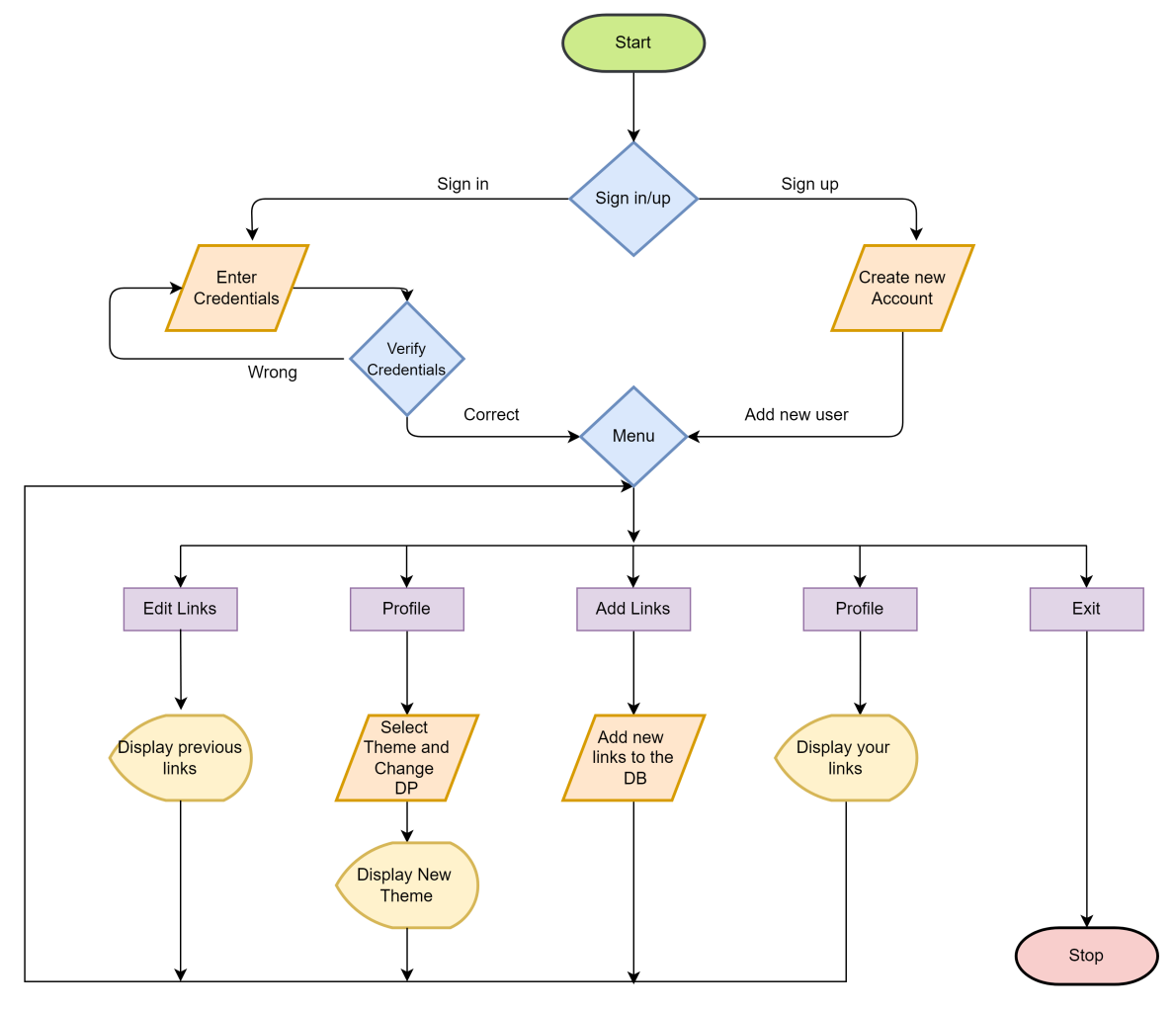
Figure 4.1: Flowchart

CHAPTER 5
IMPLEMENTATION
5.1 SIGN UP
During sign up the user is requested to enter their following details: Username(it is a unique identity used later to view the users’ profile), Email ID(Email to identify individual users uniquely to prevent spams and multiple accounts), Password(Password to validate users credentials).
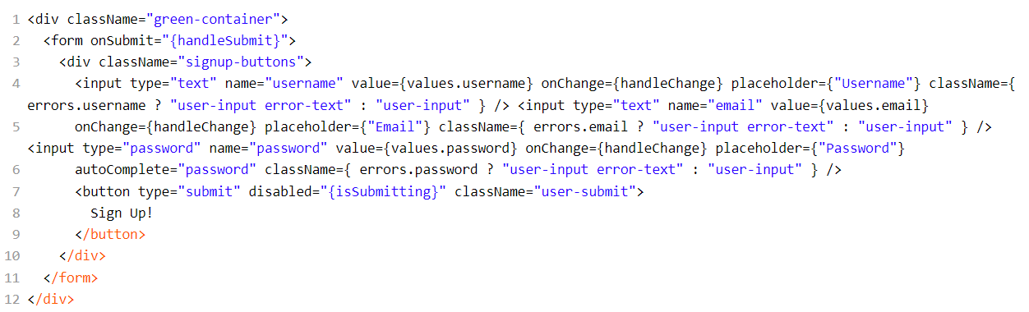
5.2 LOG IN
During log in the user is requested to enter their following details: Username and Password, the credentials are verified with the data in the database. If it is correct the user can proceed with their account else they are notified about the wrong credentials entered and requested to enter again
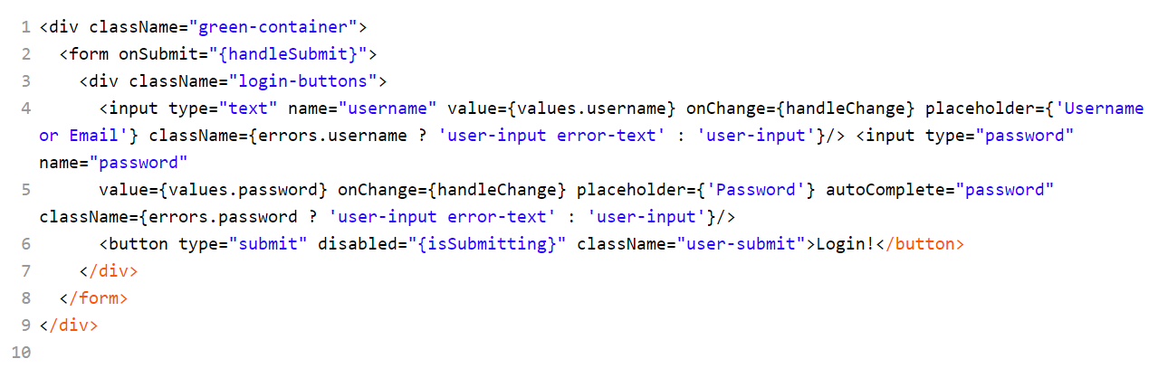
5.3 URL SHORTNER
URLs provided by the user are stored in the database and returns a shortened id.
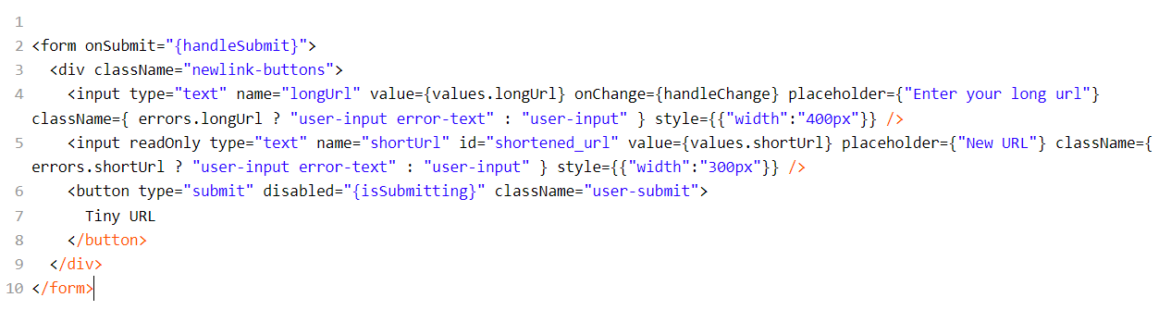
5.4 USER PROFILE
User profile contains the name of the profile and the all the links previously added by the user.
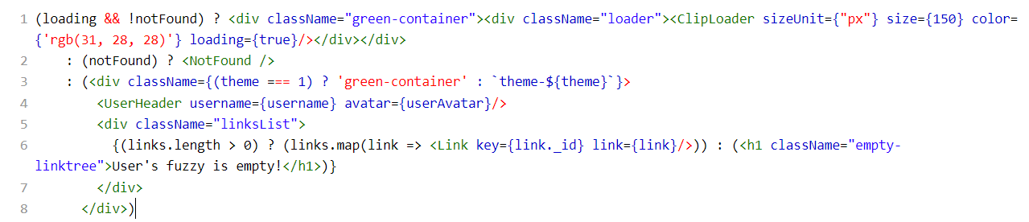
5.5 ADD LINKS
User can add a link and give it a name which can be later edited. It takes the name and the link from the user and stores it in the database of the specific user.
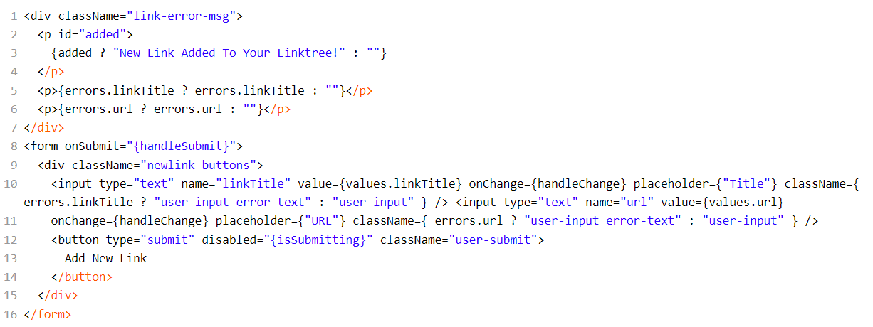
5.6 EDIT LINKS
Edit links option is to edit the links which were added by the user. The links can be edited and deleted as well.
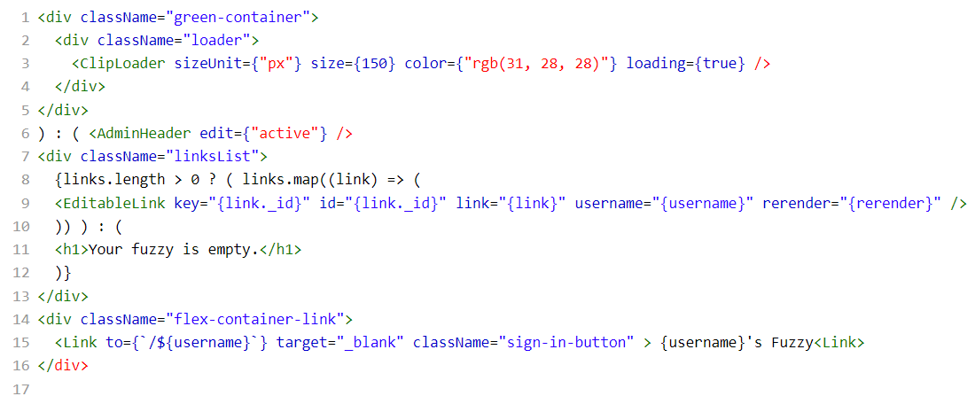
5.7 DATABASE
The database used here is the Mono DB and the connection to it is as follows.
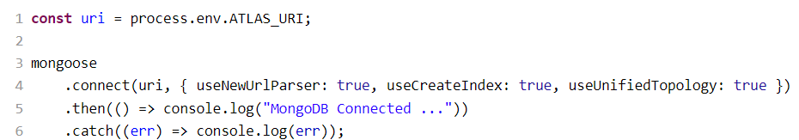
5.8 MODELS
The application has three models involved to create schemas in the database, they are as follows.
The Schema to store Shortened Links is:
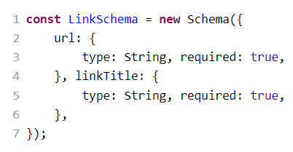
The Schema for storing Users in the database is:
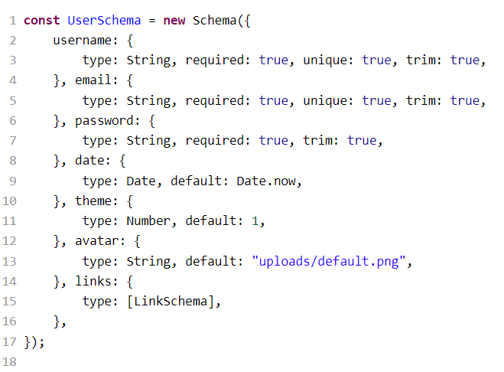
The Schema for storing and handling URL shortening is:
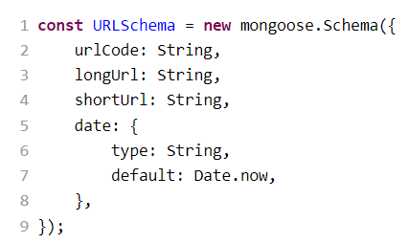

CHAPTER 6
RESULTS
6.1 LOG IN AND SIGN UP
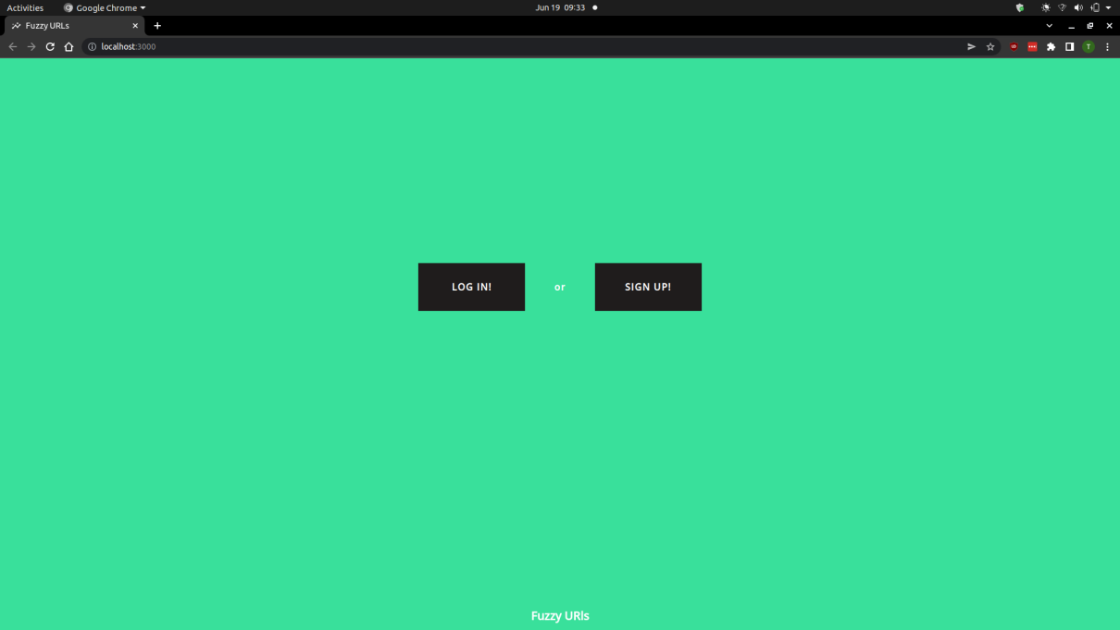
Figure 6.1: Home Screen

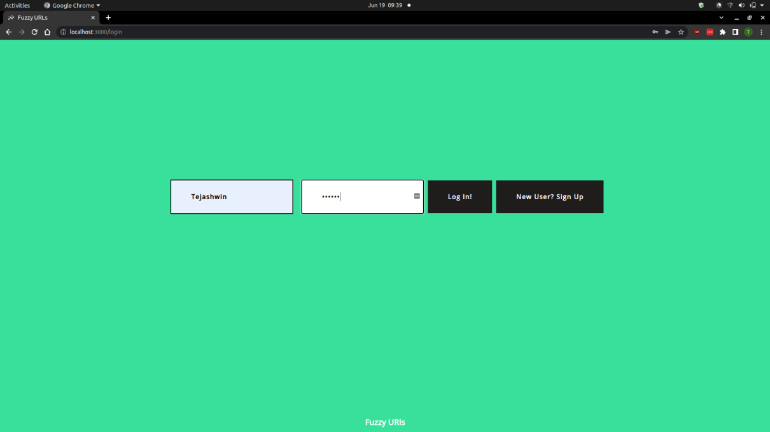
Figure 6.2: Log In Screen

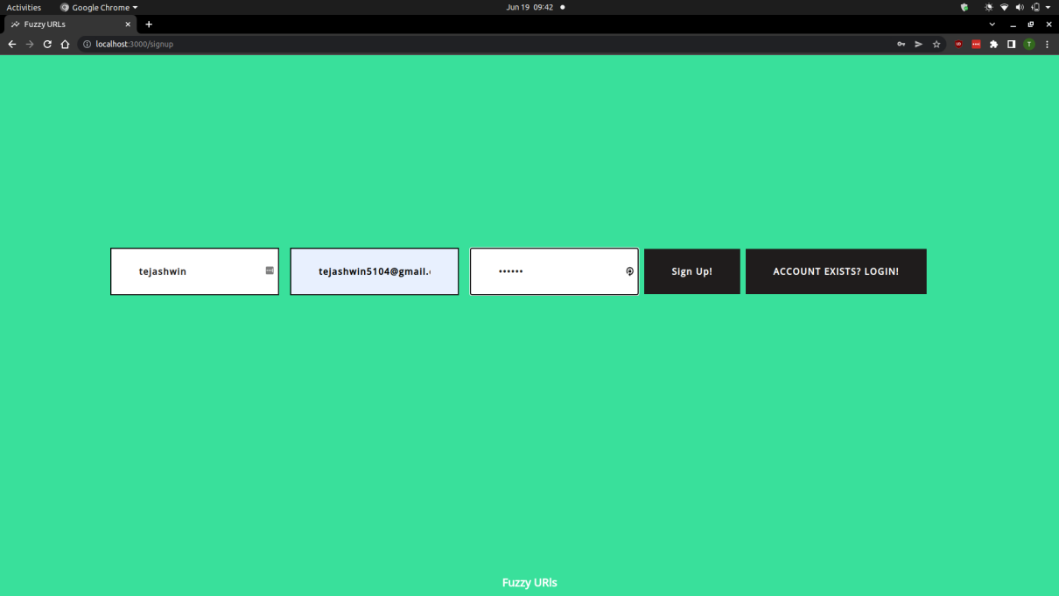
Figure 6.3: Sign Up Screen

6.2 URL SHORTNER
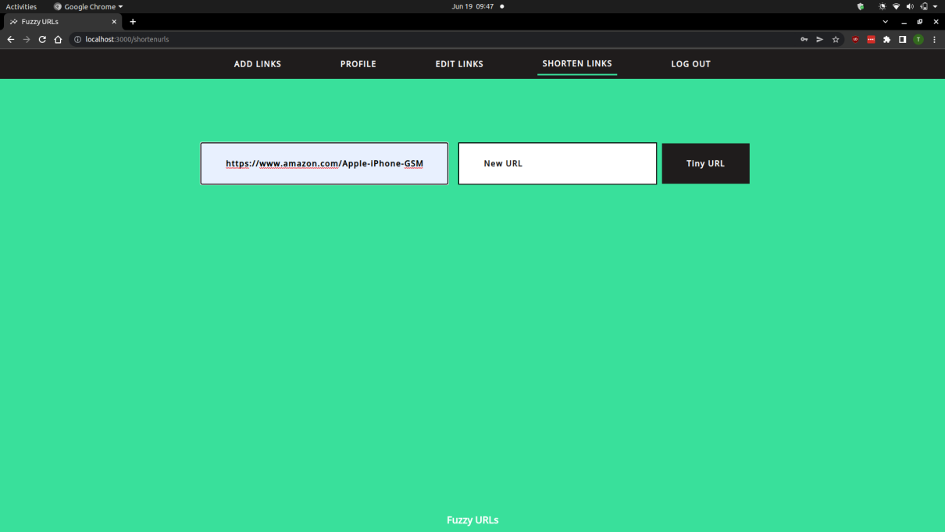
Figure 6.4: Shorten URL

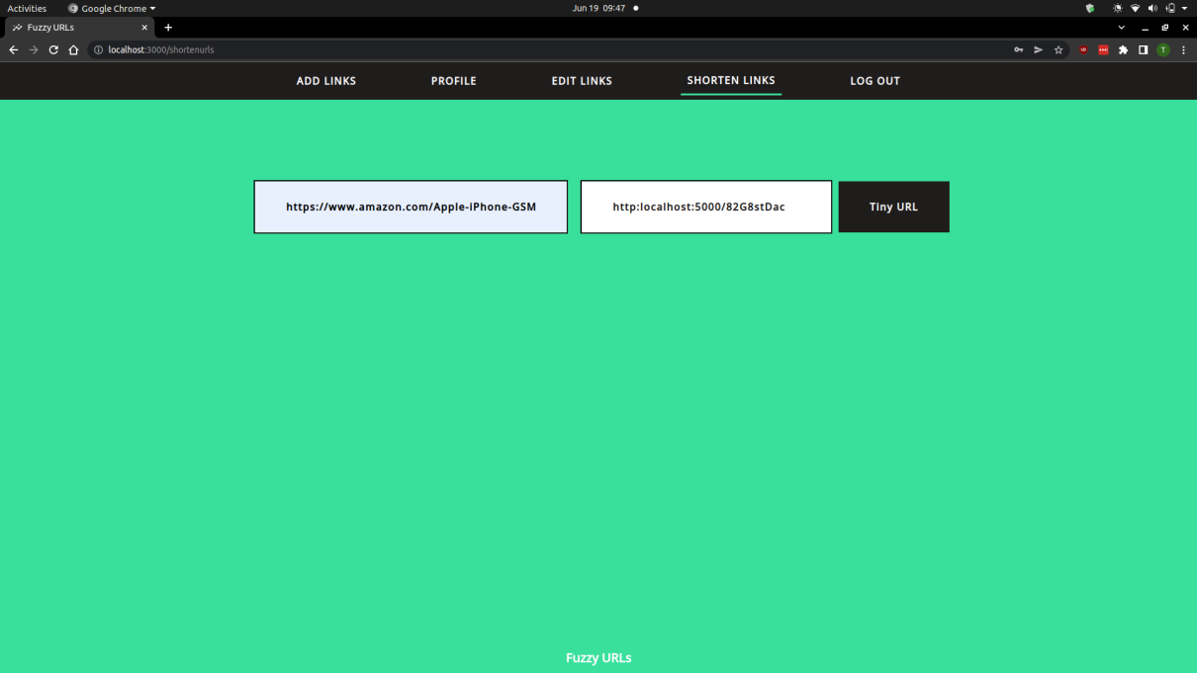
Figure 6.5: Shortened URL

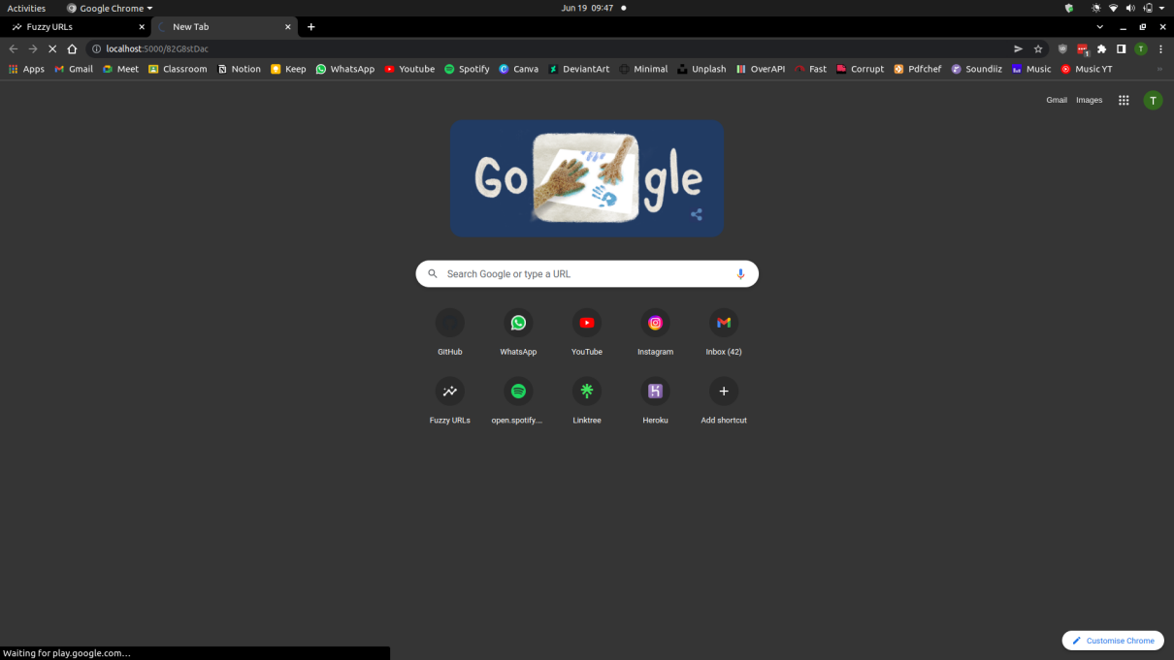
Figure 6.6: Enter Shortened URL in Browser

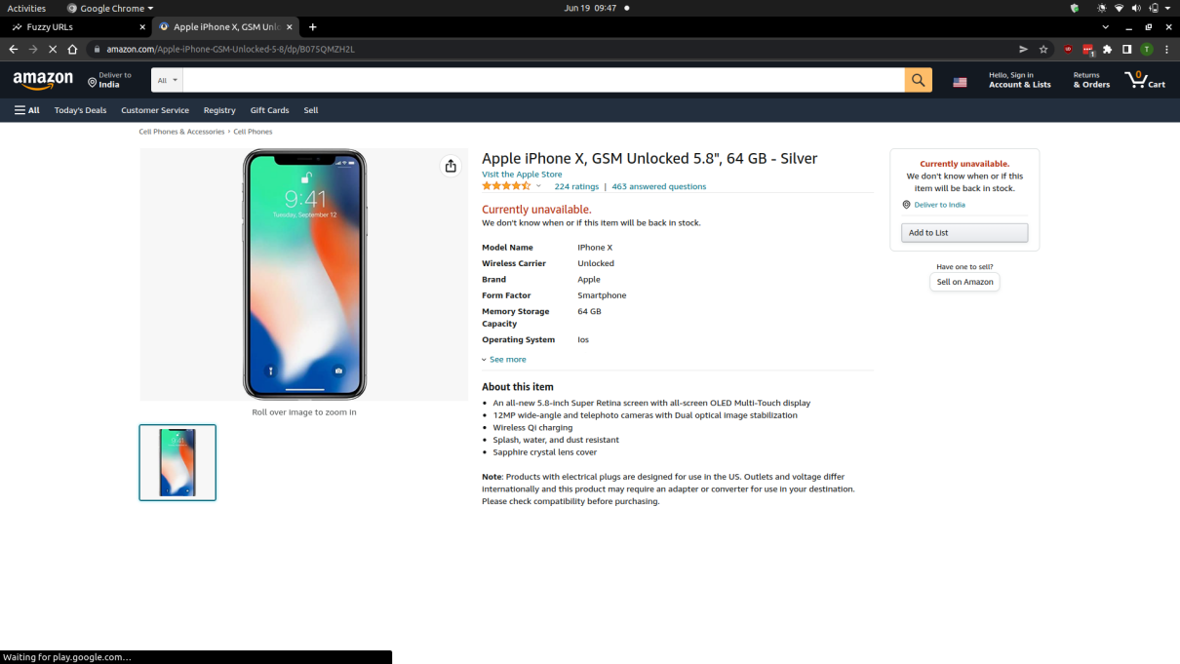
Figure 6.7: Redirect to Original URL

6.3 ADD LINKS
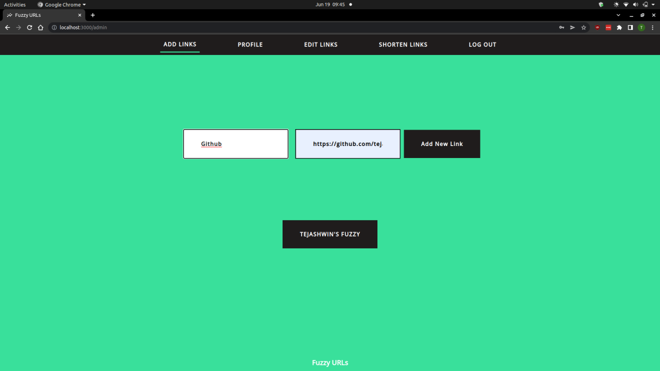
Figure 6.8: Enter New Link

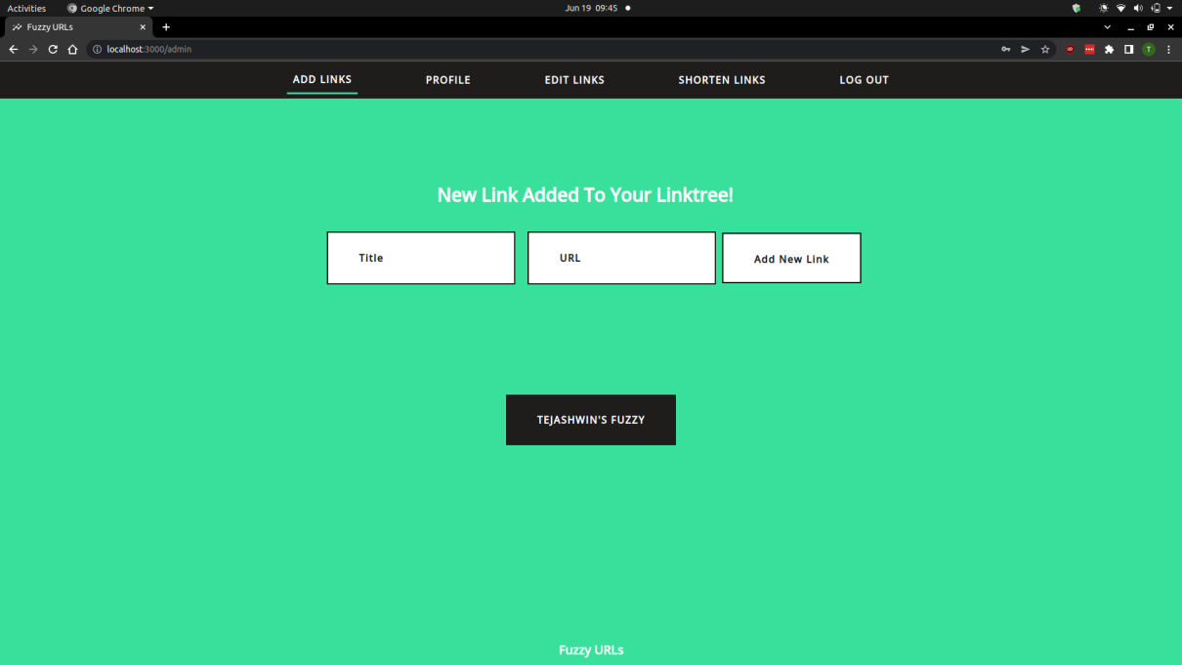
Figure 6.9: Link Added to Profile
6.4 EDIT LINKS
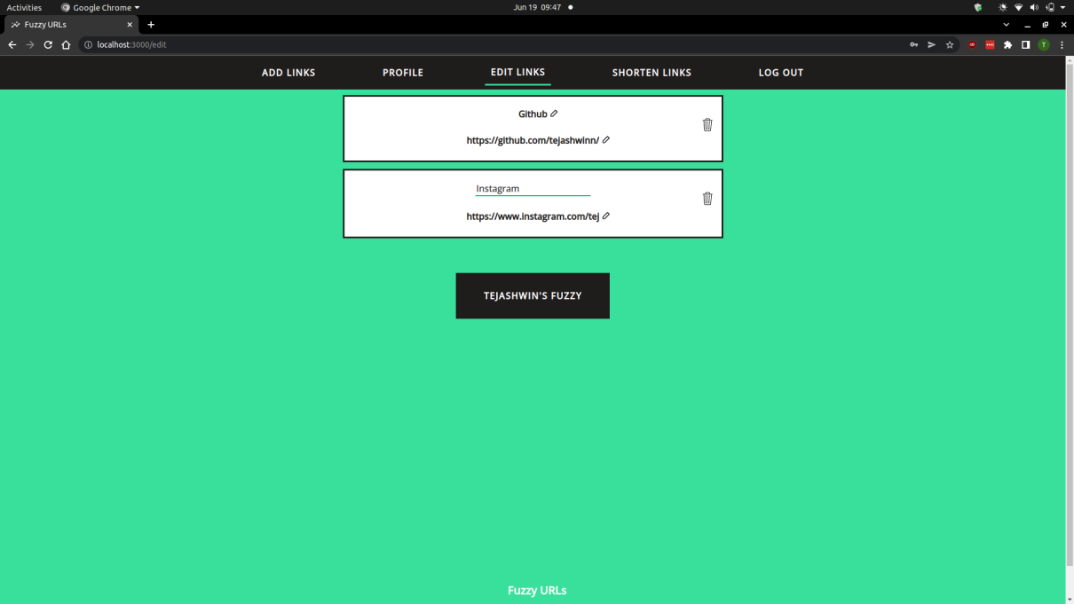
Figure 6.10: Edit Existing Added Links

6.5 EDIT PROFILE
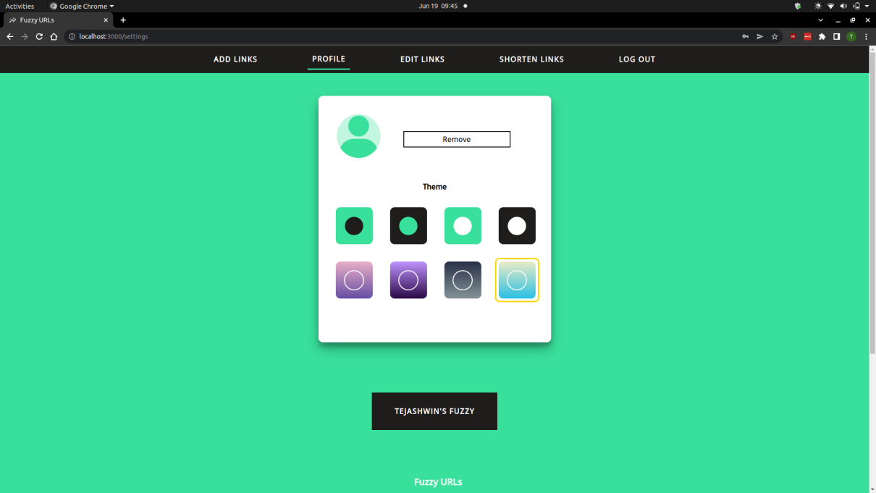
Figure 6.11: Default Profile Picture

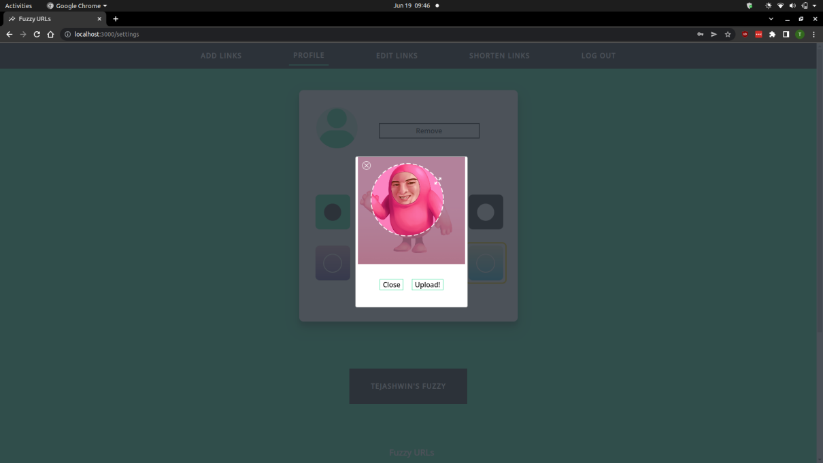
Figure 6.12: Upload Profile Picture

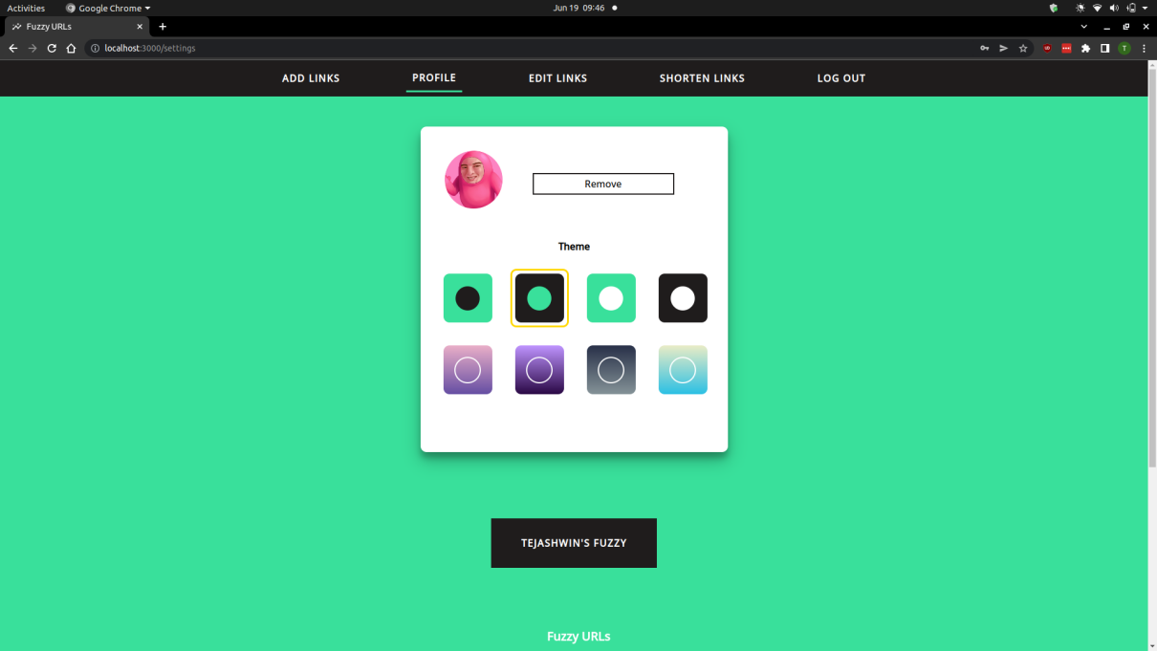
Figure 6.13: Select Theme

6.6 USER PROFILE
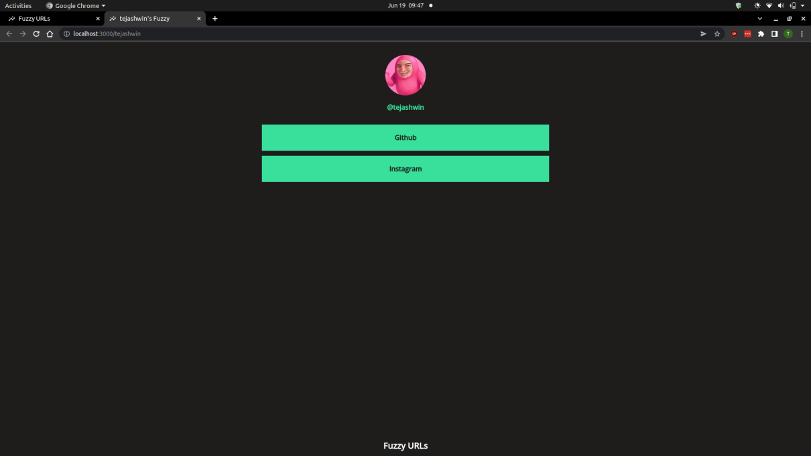
Figure 6.14: Profile Default Theme
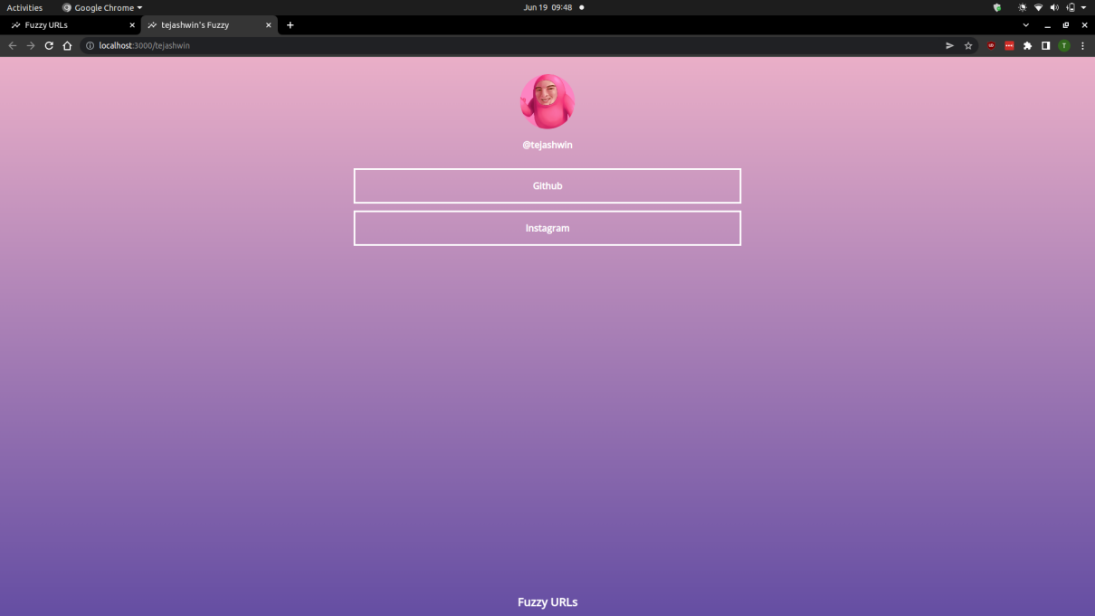
Figure 6.15: User Profile Theme-1

CHAPTER 9
CONCLUSION
The mini project has met the aims and design goals outlined in the report's objectives and design sections. Individual users can create an account to display his fuzzy. Once logged in, the user can add links URLs to their profile which re-direct the viewer to other websites/resources when clicked on necessary URL. The user can also shorten lengthy URLs to tiny URLs which is more easy to display and share among others. The users can also customize their profile by selecting from one of the eight themes provided to them and also they can upload their own profile picture.
The limitations of the application are: the shortened URLs are not linked with the user logged in, there could be better spam prevention by having two-step authentication and authorization, re-setting passwords via OTPs if the user fails to remember the password, and prevent spams for shortening URL by having an anti-bot test.

REFERENCES
- React tutorial, https://reactjs.org/tutorial/tutorial.html
- React documentation, https://reactjs.org/docs/getting-started.html
- React W3Schools tutorial, https://www.w3schools.com/REACT/DEFAULT.ASP
- Node.js W3Schools tutorial, https://www.w3schools.com/nodejs/
- Express Tutorial Point,https://www.tutorialspoint.com/expressjs/index.htm
- Express documentation, https://expressjs.com/en/5x/api.html
- Mongo DB documentation, https://www.mongodb.com/docs/
- Mongo DB tutorial, https://www.tutorialspoint.com/mongodb/index.htm
- Wikipedia, https://en.wikipedia.org/wiki/Main_Page

